Movement Through the Void
A study of galaxies in support of dark matter

Henry V. Peteet and Alex V. Loomis

Table of Contents:

- Purpose………………………………………………………….…3
- Literature Review …………………………………………………3
- Methodology…………………………………………………….…5
- Data Analysis………………………………………………………6
- Conclusions………………………………………………………...9
- Works Cited…………………………………………………….…10
- Acknowledgements ………………………………………………11

- Purpose:

We plan to show evidence of dark matter through observation of discrepancies between the predicted Keplerian galactic orbits and the corresponding real data. We hope to also investigate the distribution of this dark matter.

- Literature Review:

Much research has been gathered that is similar in concept or helpful to our Science Fair Project, most having to do with orbit modeling and galaxy distributions. Research has been conducted in areas such as initial conditions and their associated calculations by members of the Scientific Community, ranging from researchers at NASA to Professors at Cornell. Dr. Will Sutherland conducted research on the accelerations of bodies in orbits based on the gravity, mass, and radius of each respective body, concluding that the acceleration is equal to the acceleration due to gravity multiplied by the mass and all divided by the radius of the body squared (Sutherland 88). Initial conditions of the Milky Way Galaxy have been researched as well. Included in these conditions was the observable mass of the Milky Way Galaxy, which was deemed to be 1.0–1.5×1012 M☉ by Laura L. Watkins, N. Wyn Evans, and Jin H. An. (Watkins, Evans, An 1). Further, research was conducted in determining the radial scale length of the Milky Way Galaxy by Porcel, Garzon, Jimenez-Vicente, and Battaner, who stated it to be 2.1± 0.3 kpc (Porcel et al. 1).
Another important concept researched was the Shell Theorem by Isaac Newton found in the work of Jakub Schwarzmeier. It stated that ‘“a body inside a spherical shell of matter experiences no net gravitational force from the shell” (the mass exterior to the shell has no effect) and that “the gravitational force on a body lying outside a closed spherical shell experiences a gravitational force which is the same as if all the matter in the shell was concentrated at a point at its center” (Grenier, 2004)’ (Schwarzmeier 42, 43). Also included in the initial conditions were the initial orbiting velocities of bodies and the mass distribution in the Milky Way Galaxy. The former was researched by Dr. Will Sutherland and the initial velocities were determined to be solved by taking the square root of a quantity that is the acceleration due to gravity multiplied by the mass of the center all divided by the radius (Sutherland 88). The latter was researched by Jakub Schwarzmeier, who further researched the Kuzmin disk equation which was “a reasonable approximation for a disk galaxy[’s]” initial mass density distribution (Schwarzmeier 55). Finally, research was conducted on the velocities of bodies in disk galaxies, including their predicted velocities and the actual outcome of the observed velocities. This research, quite similar to what we hope to accomplish with our project, was done by K.G. Begeman, A. H. Broeils, and R. H. Sanders, who came to the conclusion that the difference in the predicted velocities and the observed velocities could be accounted for by the presence of dark matter (Begeman et al. 534, 535).

- Methodology:

Please note that for this entire project we wrote the code to analyze the data and build the model; it was not a downloaded or pre-written code of any form.

- Create a body class
  - The creation of a new class type will allow elegant and versatile code to created, and allow a simple way to save all data in a single place for each body.
  - Storage of :
    - mass
    - velocities
    - position
- Simulate acceleration due to gravity Code
  - will allow us to compute acceleration between two bodies over a timestep
- Simulate movement from acceleration Code
  - uses velocity stored in the body class to move the body a distance in a timestep
- Combine steps 1-3 to move bodies in a timestep with gravity
  - this will allow us to move bodies through gravitational fields and see realistic results.
- Test the system in step 4 by simulating the movement of the solar system
  - use realistic masses and velocities to simulate movements and allow for troubleshooting.
- Create an orbit velocity function
  - will allow the user to set the body velocity to an orbit velocity around a center mass
- Create a Kuzmin disk system for generating random bodies
  - utilize the Kuzmin disk equation to generate masses of disks which will then create the correct distribution of mass at the appropriate radii
- Combine steps 1-7
  - this will generate a random galaxy with the correct realistic input and set all the bodies to orbit correctly.
- Add animation for all the bodies and movement
  - this will allow a video to be shown while the program is running via the VPython module.
- Render and plot the velocity curve
  - add in functions to render the frames and measure the velocity at different radii
  - this will allow us to visualize the data in galaxy form and in the form of a velocity graph.
- Write dark matter compensation code:
  - Add in functions to figure out how much dark matter was needed
  - Create the dark matter needed
- Plot the dark matter distribution.

- Data Analysis:

We computed many values along the way to test the accuracy of our simulation. This included adjusting the value of the radial scale length, mass, and central mass to match other galaxies such as the andromeda galaxy. When testing gravity we made sure that our calculations were correct by simulating the solar system, and used it to show the accuracy of the system.
The ultimate visual show of our accomplishment and the massive scale of the project was the animation (see figure 1). This allowed us to view and confirm the predicted movement of the stars around the center of the galaxy. We were also able to clearly see the difference in orbit velocities of outer stars opposed to those closer in. This allowed us to observe the obvious bulge in the center that accounts for a large portion of the mass in the visible galaxy.
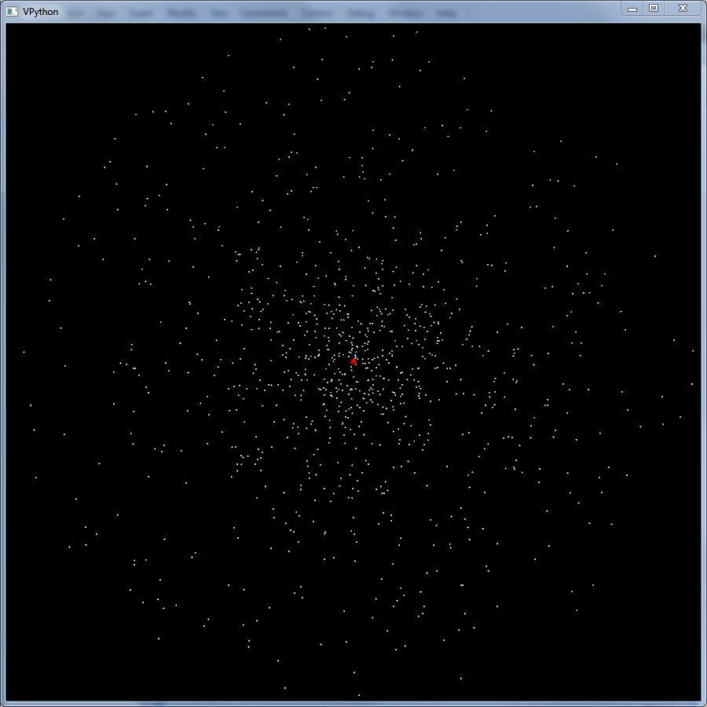
Figure 1: Rendered Frame from Animation

Despite the massive testing that we did, the majority of the useful data came in the form of the velocity curve (see figure 2). This curve was a set of data points that corresponded to the 1,000 to 10,000 points that we rendered in different simulations, but there were no discrepancies between the 1000 and 10,000 point graphs as both had more than the needed number of points to recognize the shape.

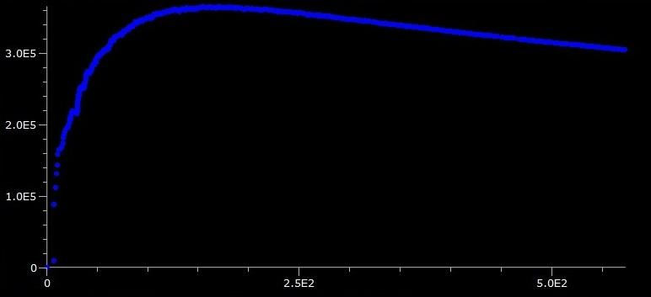

Figure 2: Predicted Velocity Curve

This was the most useful result as we were able to compare the predicted velocity to the actual velocity curve that NASA had created from observed data seen below.

As you can see on the next page in Figure 3, the actual velocity curve remains stable while the model tapers off. The increased orbit speed can only be created in the model by adding more mass, and so it stands to reason that there is in fact unseen mass hiding in the galaxies.

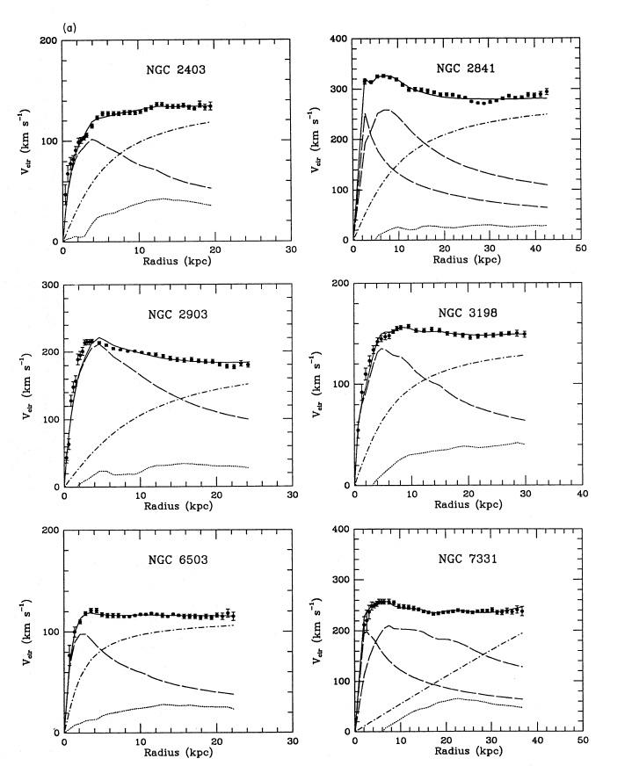

Figure 3: Velocity Graphs from NASA

After simulating a galaxy without the presence of dark matter we proceeded to add in calculated amounts of dark matter to compensate for the missing mass. This process revealed a new view of the galaxy (seen in Figure 4) and a dark matter distribution (Figure 5).
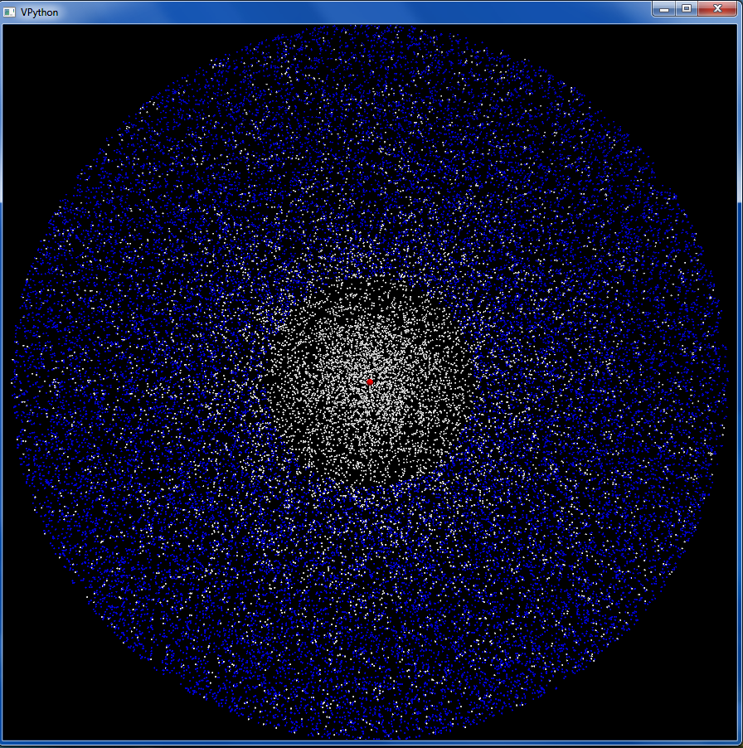
Figure 4: the generated galaxy with dark mater compensating for the lack of visible matter (Dark matter in blue, visible mater in white)
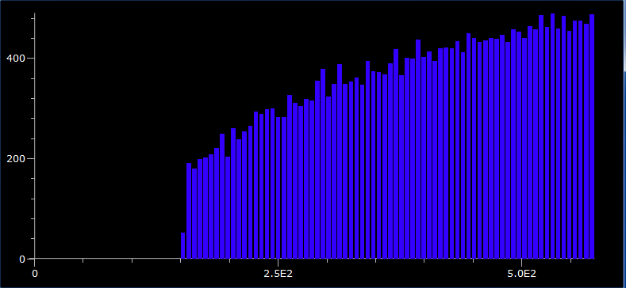
Figure 5: the distribution of dark matter (amount of dark mater vs. radial distance)

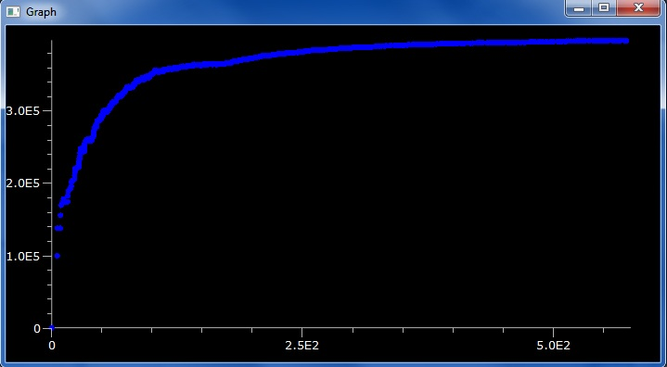
When the dark matter was added to the simulation we obtained a more realistic velocity graph seen below in Figure 6.
Figure 6: New velocity graph after dark matter was added.
- Conclusion:
Our models showed that there was a need for dark matter in galaxies, affirming our statement of intent. The models predicted the movement of stars within the galaxies accurately, according to the Keplerian model, while the real data contradicted the model; this gave us evidence for dark matter. These models were accurate: the data collected from them matched professional work from NASA. The most significant takeaway was the difference in the velocity curves of galaxies. While our velocities began to fall shortly after the radius exceeded the dense central bulge of the galaxy, the real curve remains constant and does not taper off. This is astounding considering that once the radius is beyond a majority of the galactic mass, the velocity should decrease consistently. This proposes a new view of galaxies constructed of small amounts of visible matter, surrounded by immense clusters of dark matter that maintain the outer orbit velocities. From measuring this distribution we can observe that dark matter exists more frequently in outer regions of galaxies.

- Works Cited:

Begeman, K. G., A. H. Broeils, and R. H. Sanders (2012), "Extended Rotation Curves of Spiral Galaxies: Dark Haloes and Modified Dynamics." NASA Astrophysics Data System.
(2007) "Galaxies." McGraw-Hill Encyclopedia of Science & Technology. New York: McGraw-Hill. Print.
Moore, Patrick (2003) Astronomy Encyclopedia [an A-Z Guide to the Universe]. New York: Oxford UP. Print.
Porcel, C., F. Garzon, J. Jimenez-Vicente, and E. Battaner. (2008) "The Radial Scale of the Milky Way." Astronomy and Astrophysics: 1-5. Print.
Ridpath, Ian, (2001), The Illustrated Encyclopedia of the Universe. New York: Watson-Guptill Publications. Print.
Schwarzmeier, Jakub. (2007) "On Simulations of Galaxy Dynamics and Their Application to Physics Education." Diss. University of West Bohemia in Pilson, Print.
Sutherland, Will. (2012) "Rotation Curves." Reading. The Galaxy. 27 Apr. 2012. The Galaxy. Web. <http://www.maths.qmul.ac.uk/~wjs/MTH726U/>.
Tamm, A., and P. Tenjes. (2003) "Structure and Mass Distribution of Spiral Galaxies at Intermediate Redshifts." Astronomy and Astrophysics 403.2: 529-36. Print.
Watkins, Laura L., N. Wyn Evans, and Jin H. An. (2010) "The Masses of the Milky Way and Andromeda Galaxies." Monthly Notices of the Royal Astronomical Society: 1-15. Print.
Zonoozi, Akram Hasani, Andreas H. W. Küpper, Holger Baumgardt, Hosein Haghi, Pavel Kroupa, and Michael Hilker.(1998-2001) "Direct N-body Simulations of Globular Clusters - I. Palomar 14." Monthly Notices of the Royal Astronomical Society 411.3 (2011): Print.
- Acknowledgements

We would like to thank Dr. Schatz for the meeting with us early on in the process and his valuable input on the modeling of galaxies. In addition, we would like to thank our sets of parents that let us stay up late coding, and our teacher Mr. Nichols who turned us onto the idea of working with the stars.

